Aphanocapsa sp. Nägeli 1849
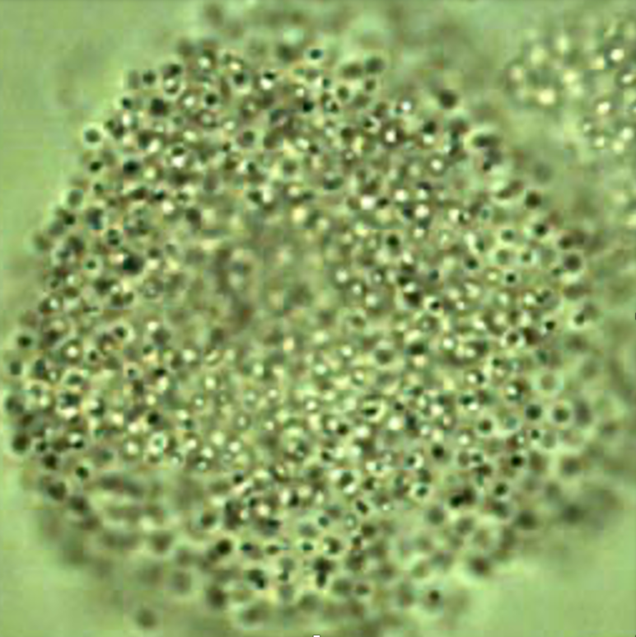
Phylum: Cyanobacteriophyta
Class: Cyanophyceae
Order: Chroococcales

Habitat: plankton
Distinctive features: spherical colonies of densely packed minute-size cells.
Organization: colonies
Color: pale blue-green
Cell shape: sphere
Colony shape: sphere or close to a sphere
Cell diameter (D): 0.5-1.0 μm.
Cell biovolume: 0.06-0.5 μm³
Biovolume equation: Sphere V, µm³ = 4/3 π (D/2)³.
Colony diameter: ~50-200 μm
Cells per colony: hundreds to thousands

Morphological features: Colonies with many closely packed tiny (0.4-1.0 μm diameter) spherical cells with no gas vacuoles, irregularly arranged and embedded in mucilage with indistinct outer margin. Rare. Identified only to genus level.
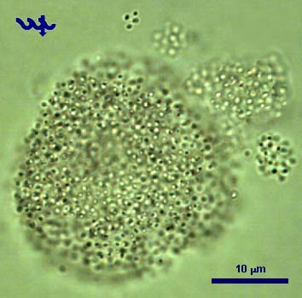
Plate 1. Large and small colonies of Aphanocapsa sp. Photo by Alla Alster.

Ecology: Rare in Lake Kinneret, we have no ecological data for this genus.

Cite this record as:
Tamar Zohary, Alla Alster. [Date when Item was last updated]. Electronic publication. Israel Oceanographic & Limnological Research. [Date when last accessed].

Aphanothece stagnina (Sprengel) A. Braun 1863
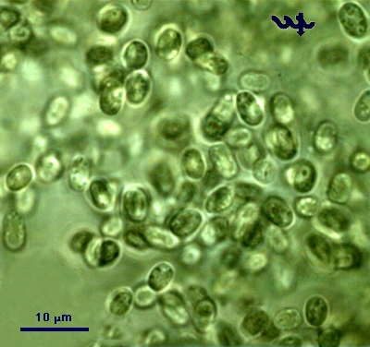

Phylum: Cyanobacteriophyta
Class: Cyanophyceae
Order: Chroococcales

Habitat: benthos, littoral
Distinctive features: colonial, forming masses in ankle-deep water near shore
Organization: colonial
Color: brown to olive-green
Cell shape: cylinders with rounded ends
Colony shape: sphaerical and various shapes formed when a sphere gets pushed, pulled or twisted
Cell diameter (D): 3–5 μm
Cell length (L): 4–11 μm
Colony diameter: up to 1-2 cm

Morphological features: large brown to olive-green colonies made of densly packed ovoid cells, floating in shallow water near the lake’s waterline. Colonies can reach diameter >1 cm and are seen with a naked eye. Prokaryotic cells with no individual sheath.
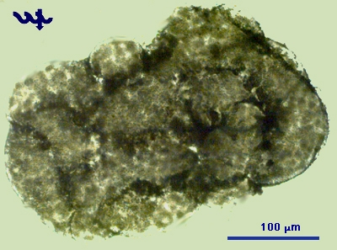
Plate 1. A colony of Aphanothece stagnina from the shore of Lake Kinneret, Aug 2008. Photo by Alla Alster.
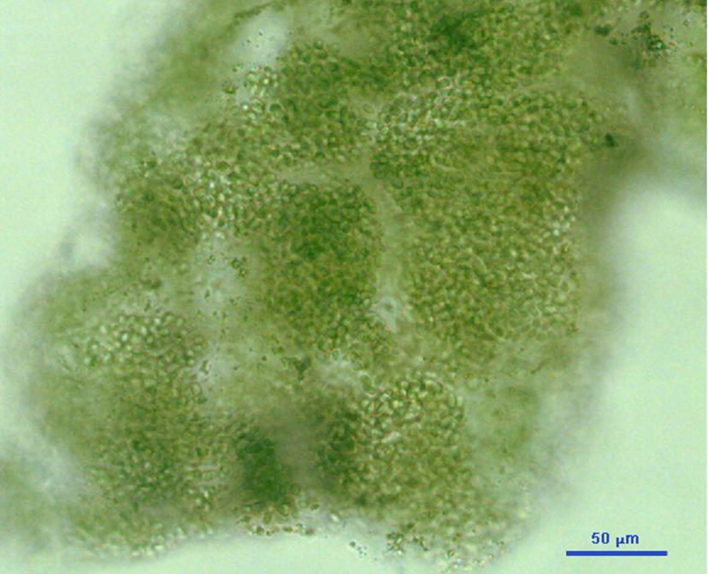
Plate 2. Higher magnification on a colony of Aphanothece stagnina from the shore of Lake Kinneret, 2008. Photo by Alla Alster.

Plate 3. Close-up on individual cells in a colony of Aphanothece stagnina from the shore of Lake Kinneret, 2008. Photo by Alla Alster.

Ecology: Initial development is benthic, but mature colonies float to the surface and are wind-driven to form shoreline accumulations. Masses of this species were seen in Lake Kinneret only once during Summer-fall 2008. At other times, occasionally a few colonies are observed.

Cite this record as:
Tamar Zohary, Alla Alster. [Date when Item was last updated]. Electronic publication. Israel Oceanographic & Limnological Research. [Date when last accessed].

Chroococcus limneticus Lemmermann 1898
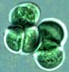
Phylum: Cyanobacteriophyta
Class: Cyanophyceae
Order: Chroococcales

Habitat: planktonic
Distinctive features: rare.
Organization: colonies of 2-8 cells, rarely as single cells
Color: blue-green
Cell shape: sphere
Colony shape: spherical
Cell diameter (D): 4 – 10 μm
Cell biovolume: 35 – 500 μm³
Biovolume equation: Sphere V, μm³ = 4/3 π (D/2)³
Colony diameter:
Cells per colony: 4-30

Morphological features:
Colonies of 4-30 sperical cells that remain attached after cell division (Plate 1, 2). With wide colorless translucent gelatinous slime (Plates 1, 2). With envelopes around cells. No gas vacuoles.

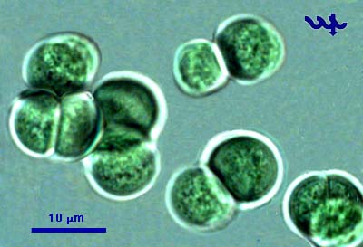
Plate 1. Chroococcus limneticus from Lake Kinneret. Cells remain attached after division, have no gas vacuoles, with a distinct envelope. Photo by Alla Alster, Aug. 2007.
Plate 2. Chroococcus limneticus from Lake Kinneret, shore sample. Photo by Alla Alster, Sep. 2007.

Ecology: The species rarely occurs (Fig. 1).
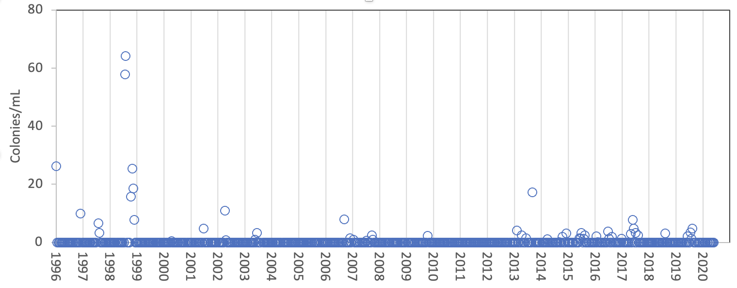
Figure 1. Time series of Chroococcus limneticus mean epilimnion colony abundance (colonies mL⁻¹) Lake Kinneret, 1996-2020.

Environmental conditions:
Chroococcus limneticus was more abundant at warmer water temperatures, lower alkalinities, and higher pH – to a limit of pH 9.0 (Fig. 2).

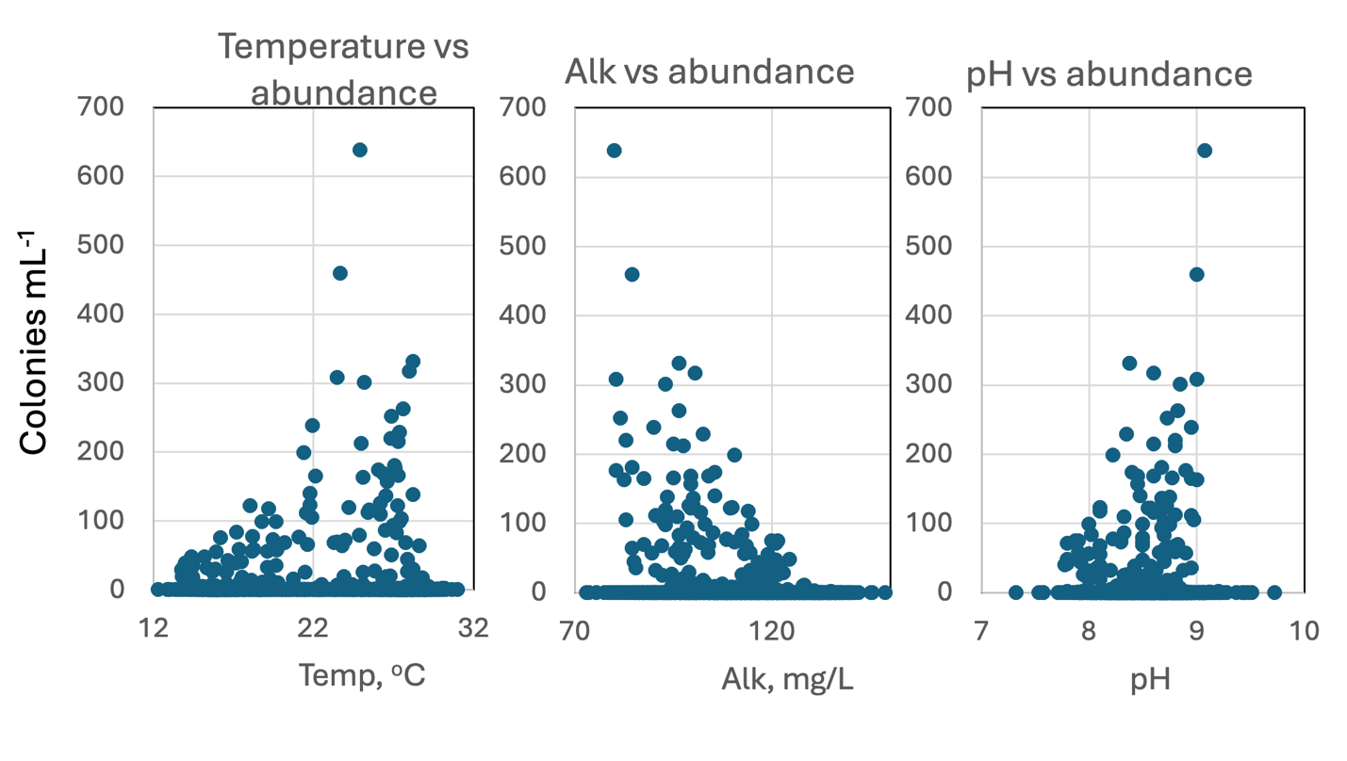Figure 2. Chroococcus limneticus abundance (colonies mL⁻¹) vs. environmental parameters recorded at the site and time of sampling, showing tendency for higher abundance at higher temperature, lower alkalinities and higher pH (to a limit at 9.0).
Cite this record as:
Tamar Zohary, Alla Alster. [Date when Item was last updated]. Electronic publication. Israel Oceanographic & Limnological Research. [Date when last accessed].

Chroococcus minutus (Kützing) Nägeli 1849
Phylum: Cyanobacteriophyta
Class: Cyanophyceae
Order: Chroococcales

Habitat: planktonic
Distinctive features: single spherical cells or couples of hemispherical cells after cell division, surrounded by a wide colorless homogeneous sheath.
Organization: single cells or colonies of 2 (most common) to 8 cells
Color: blue-green
Cell shape: sphere
Colony shape: spherical
Cell diameter (D): 3 – 10 μm, median: 5.9 μm (N=1500). Cell diameter varies significantly over an annual cycle, making it necessary to measure it routinely.
Cell biovolume: 20 – 500 μm³, median: 110 μm³. Larger cell size in winter, smaller in summer (see Fig. 2).
Biovolume equation: Sphere V, μm³ = 4/3 π (D/2)³.
Morphological features: Individual spherical blue-green colored cells are surrounded by a wide colorless homogeneous sheath (Plate 1). The species is polymorphic with numerous morpho-and ecotypes. Chroococcus turgidus and Chroococcus minutus are difficult to tell apart. The most notable difference is that the sheath of C. minutus is usually homogeneous with no layering while that of C. turgidus is laminated (layered). Furthermore, on average C. minutus cells are smaller, but both species show large size variation and the sizes overlap.
Plate 1. Chroococcus minutus from the pelagic waters of Lake Kinneret, showing a single cell with its typical thick homogeneous sheath (bottom) and two cell couples with their shared sheath. The right couple of cells are infected by bateria. Photo by Alla Alster, July 2026.

Ecology: An alanlyst effect is apparent in the long-term record of C. minutus and C. turgidus shown in Fig. 1. In particular, it is evident that Analyst 5 (1996-2012) counted more C. minutus whereas Analyst 6 (2013-2020) counted more C. turgidus, probably due to different taxon names given to the same organisms. Chroococcus minutus / turgidus has always been common in lake Kinneret, with long periods of thousands of (mostly 2-celled) colonies mL⁻¹ (Fig. 1). Prior to the decline of Peridinium gatunense and appearance of nostocalean cyanobacteria in the mid 1990s Chroococcus was the most abundant Kinneret cyanobacterial taxon. Peak abundance is from August to October (Fig. 2). Like several other Kinneret species, cells are smaller in summer, larger in winter (Fig. 2).

Environmental conditions: Advantaged by high water temperatures (>25ºC) and a well-stratified water column. Indifferent to chloride concentrations.
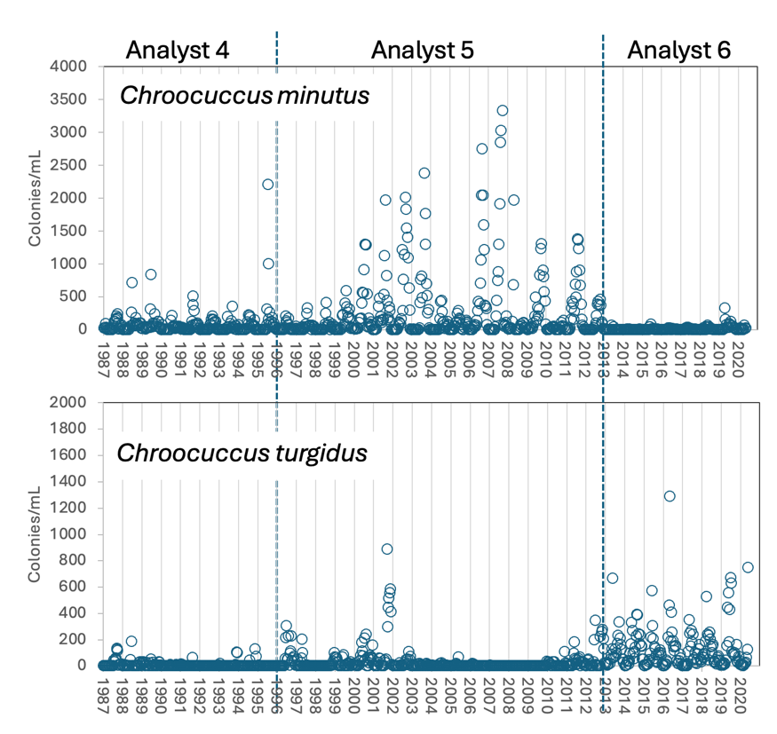
Figure 1. Time series of Chroococcus turgidus and Chroococcus minutus mean epilimnion colony abundance (colonies mL⁻¹) Lake Kinneret, 1987–2020, showing a distinct Analyst Effect.
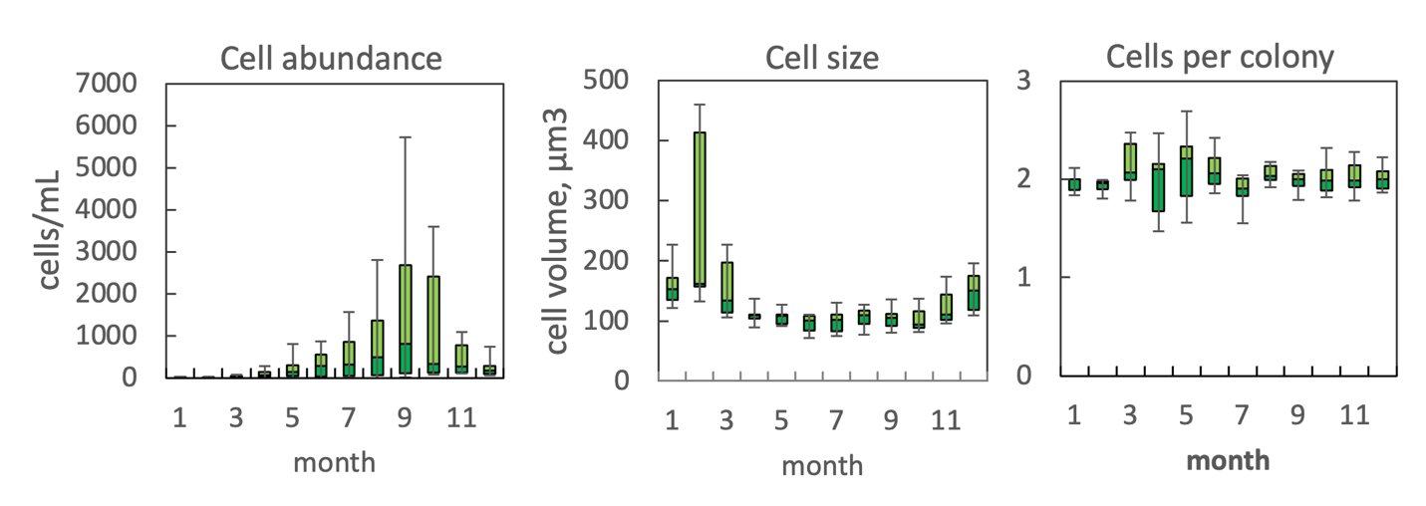Figure 2. The annual pattern of water column cell abundance (left) and volume per cell (middle) and number of cells per colony (right) of Chroococcus minutus, based on data for 2004-2012 (Analyst 5 only). Statistics shown are: median – middle line; 25th to 75th percentiles – box content; 90th and 10th percentiles - top and bottom bars, respectively.

Cite this record as:
Tamar Zohary, Alla Alster. [Date when Item was last updated]. Electronic publication. Israel Oceanographic & Limnological Research. [Date when last accessed]

Chroococcus turgidus (Kützing) Nägeli 1849
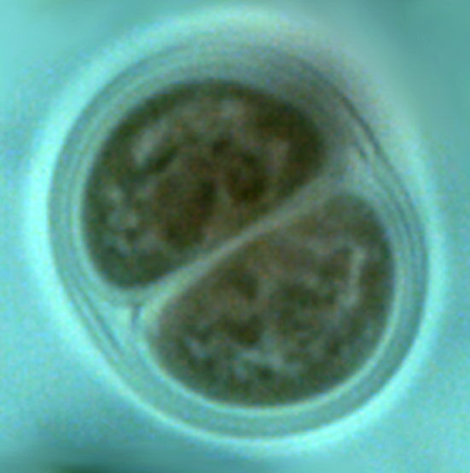
Phylum: Cyanobacteriophyta
Class: Cyanophyceae
Order: Chroococcales

Habitat: planktonic
Distinctive features: single strongly pigmented cells or more often two cells, or occasionally small colonies of few cells in distinct, thick colorless envelope(s).
Organization: single cells or colonies of 2 (most common) to 8 cells
Color: blue-green
Cell shape: sphere
Colony shape: spherical
Cell diameter (D): 4 – 13 μm, median: 6.2 μm (N=502). Cell diameter varies significantly over an annual cycle, making it necessary to measure it routinely.
Cell biovolume: 40 – 200 μm³. Larger cell size in winter, smaller in summer (see Fig. 2).
Biovolume equation: Sphere V, μm³ = 4/3 π (D/2)³.

Morphological features: Individual spherical cells are surrounded by hyaline lamellate sheaths. After division the original sheath remains around each new cell but an additional sheath envelopes both cells, now hemispherical in their shape, that remain attached (Plates 1). The cells are strongly colored, the envelopes are colorless but distinct (Plate 2). Chroococcus turgidus and Chroococcus minutus are difficult to tell apart. The only easy to notice difference is that the envelopes of C. turgidus are laminated (layered), whereas that of C. minutus typically show no layering. On average, C. minutus cells are smaller, but both species show large size variation and the sizes overlap.
Plate 1. Chroococcus turgidus. Two hemispherical cells that remain attached after division. Each cell is surrounded by its own sheath, and another sheath that envelopes both cells. Photo by Alla Alster, 2006.
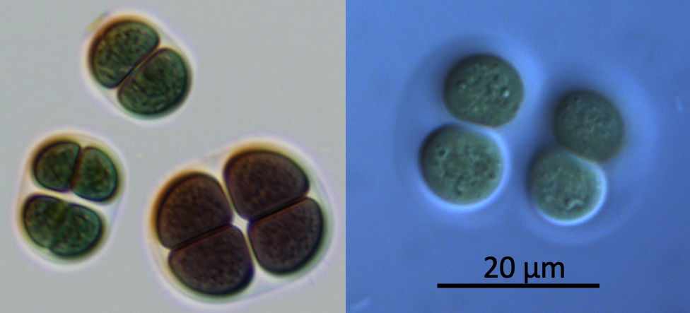
Plate 2. Large cells of Chroococcus turgidus from the littoral zone. Couples of hemispherical cells that remain attached after division are surrounded by their own sheath, and another sheath that envelopes four cells. Photo by Alla Alster, 2019.

Ecology: An alanlyst effect is apparent in the long-term record of C. minutus and C. turgidus shown in Fig. 1. In particular, it is evident that Analyst 5 (1996-2012) counted more C. minutus whereas Analyst 6 (2013-2020) counted more C. turgidus, probably due to different taxon names given to the same organisms. Chroococcus minutus / turgidus has always been common in lake Kinneret, with long periods of thousands of (mostly 2-celled) colonies mL⁻¹ (Fig. 1). Prior to the decline of Peridinium gatunense and appearance of nostocalean cyanobacteria in the mid 1990s Chroococcus was the most abundant Kinneret cyanobacterial taxon. Like several other Kinneret species, cells are smaller in summer, larger in winter (Fig. 2).
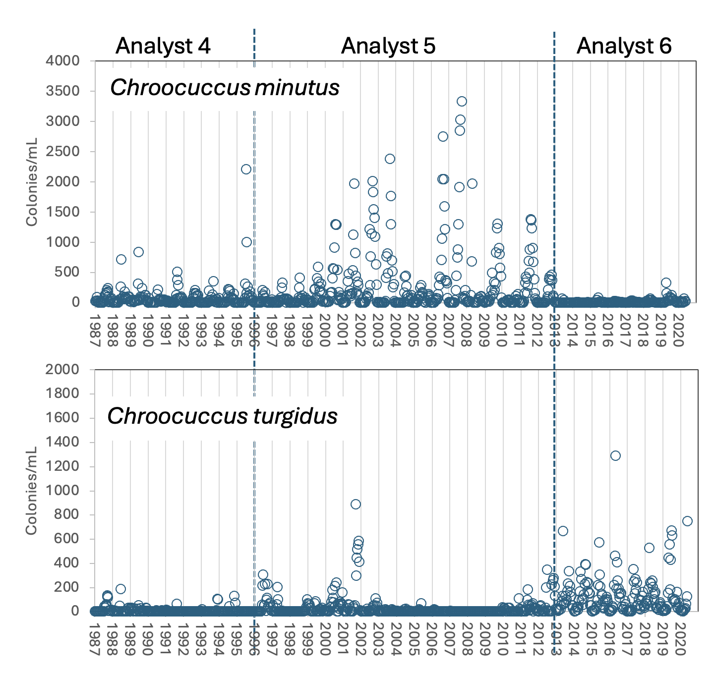
Figure 1. Time series of Chroococcus turgidus and Chroococcus minutus mean epilimnion colony abundance (colonies mL⁻¹) Lake Kinneret, 1987–2020, showing a distinct Analyst Effect.
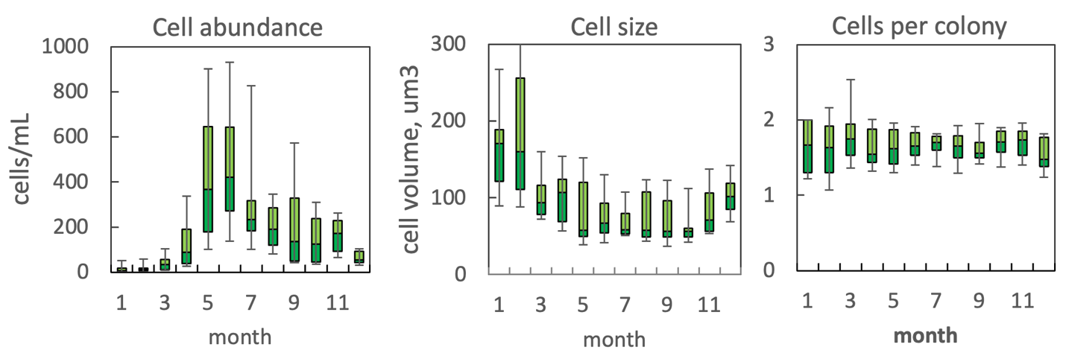
Figure 2. The annual pattern of water column cell abundance (left) and volume per cell (middle) and number of cells per colony (right) of Chroococcus turgidus, based on data for 2013-2020 (Analyst 6 only). Statistics shown are: median – middle line; 25th to 75th percentiles – box content; 90th and 10th percentiles - top and bottom bars, respectively.

Environmental conditions:
Chroococcus turgidus is more abundant at temperature > 22 C. It occurs at all chloride concentrations.
Cite this record as:
Tamar Zohary, Alla Alster. [Date when Item was last updated]. Electronic publication. Israel Oceanographic & Limnological Research. [Date when last accessed].
Further reading:
Zohary T, Fishbein T, Shlichter M, Naselli-Flores L (2017) Larger cell or colony size in winter, smaller in summer – a pattern shared by many species of Lake Kinneret phytoplankton. Inland Waters 7:200-209.

Cyanodictyon imperfectum Cronberg et Weibull 1981
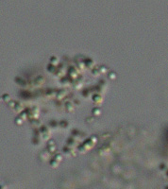

Phylum: Cyanobacteriophyta
Class: Cyanophyceae
Order: Chroococcales

Habitat: plankton
Distinctive features: tiny colonies of minute cells, extremely abundant from June to August. No cyanotoxins are known for this species.
Organization: colonies
Color: brown
Cell shape: sphere
Colony shape: variable
Cell diameter (D): 0.4-1.0 μm.
Cell biovolume: 0.06-0.5 μm³
Biovolume equation: Sphere V, µm³ = 4/3 π (D/2)³.
Colony diameter: 10-100 μm
Cells per colony: 2 to hundreds

Morphological features:
The tiny (0.4-1.0 μm diameter) spherical cells of this colonial cyanobacterium have no gas vesicles. They are arranged in short chains of 2-8 cells that are embedded in colorless structureless mucilage to form small colonies (Plates 1, 2). This is the smallest-cell species being counted in our routine monitoring. The amount of mucilage and distance between chains are highly variable.
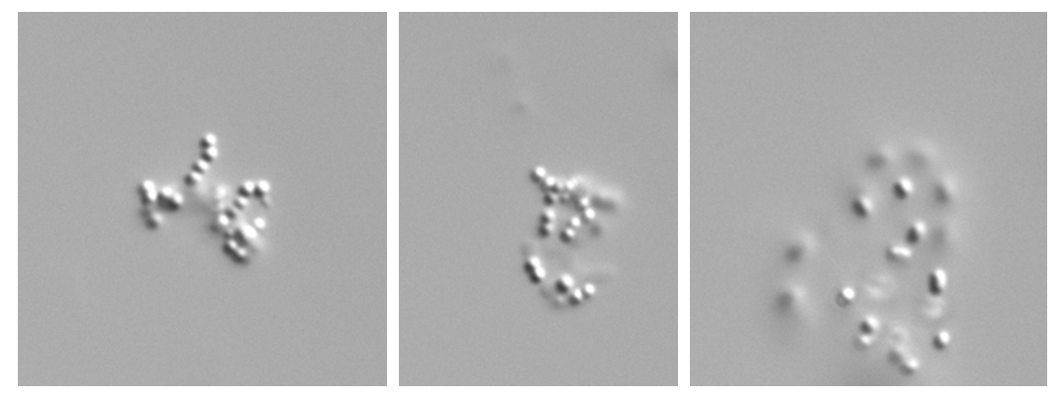
Plate 1. Colonies of Cyanodictyon imperfectum. Cells are minute, < 0.5 µm diameter, organized in short filaments with large spaces between them, filaments are organized into a colony with no distinct order. Photos by Alla Alster, July 2026.

Ecology: Cyanodictyon imperfectum is routinely counted since 1996, forming blooms of thousands of colonies per mL (Fig. 1) with hundreds of thousands of cells per mL (not shown) from June to August each year, with a distinct peak in July. But due to the tiny cell size the contribution of Cyanodictyon to total phytoplankton biomass, even during those blooms, never exceeds a few percent. Particularly intense blooms of this species were recorded in 2000, 2003, 2007 and nearly every year since 2015 (Fig. 1). Colony size shows a strong seasonal cycle with larger colonies (more cells per colony) in winter, when the species abundance is low, and smaller colonies in summer when abundance is high (Fig. 2). This seasonal pattern of being larger in winter, at lower water temperatures, is shared with many other Kinneret phytoplankton species (Zohary et al. 2017).

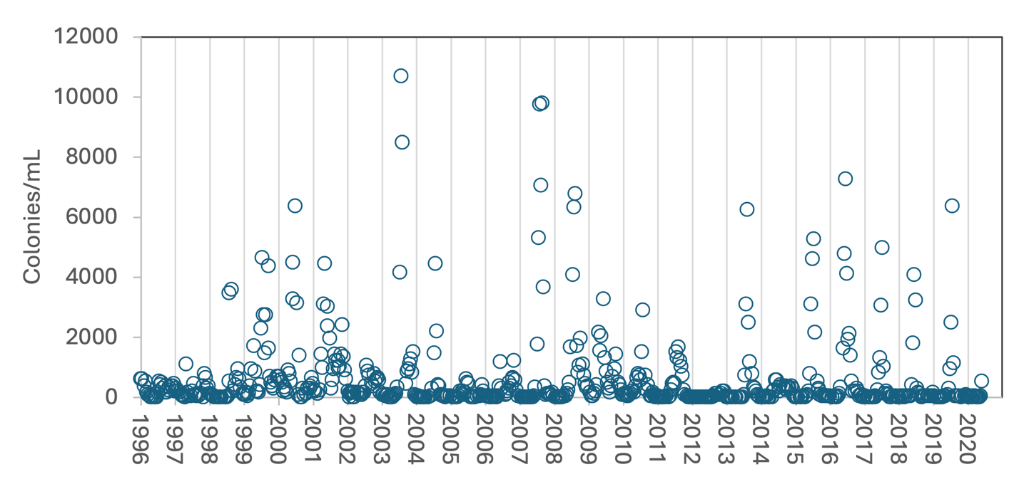
Figure 1. Time series of Cyanodictyon imperfectum mean epilimnion abundance (colonies mL⁻¹), Lake Kinneret, 1996-2020.

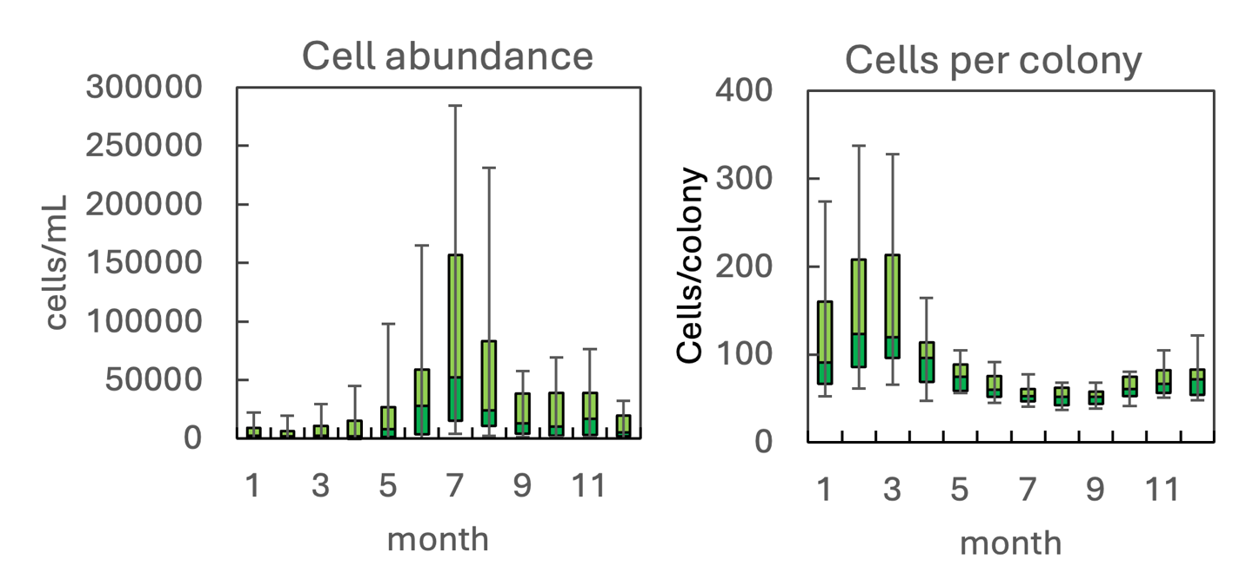Figure 2. The annual pattern of water column cell abundance (left) and colony size (right) of Cyanodictyon imperfectum, based on Kinneret monitoring data for 1996 -2020. Statistics shown are: median – middle line; 25th to 75th percentiles – box content; 90th and 10th percentiles - top and bottom bars, respectively.

Physiological features: capable of precipitating iron-oxide which is deposited externally in the mucilage between two adjacent cells in the form of dense rings, these can be observed by electron microscopy.
Environmental conditions: Cyanodictyon imperfectum abundance is independent of concentrations of chloride and total dissolved P (TDP), it increases with water temperature and declines with increasing alkalinity and calcium concentration (Fig. 3). It is highest at moderate dissolved organic N concentrations (0.1-0.4 mg L⁻¹), at low NH₄ (< 0.05 mg L⁻¹) and NO₃ (<0.2 mg L⁻¹). Highest abundances also correlate with low chlorophyll concentrations (< 400 mg m⁻²), intermediate Secchi depth (2-4 m), and pH of 8-9 (Fig. 3). Larger colony size (more cells/colony) is strongly correlated with low temperature (<20ºC), alkalinity > 130 mg CaCO₃ mL⁻¹, and Ca > 50 mg L⁻¹ (Fig. 4).
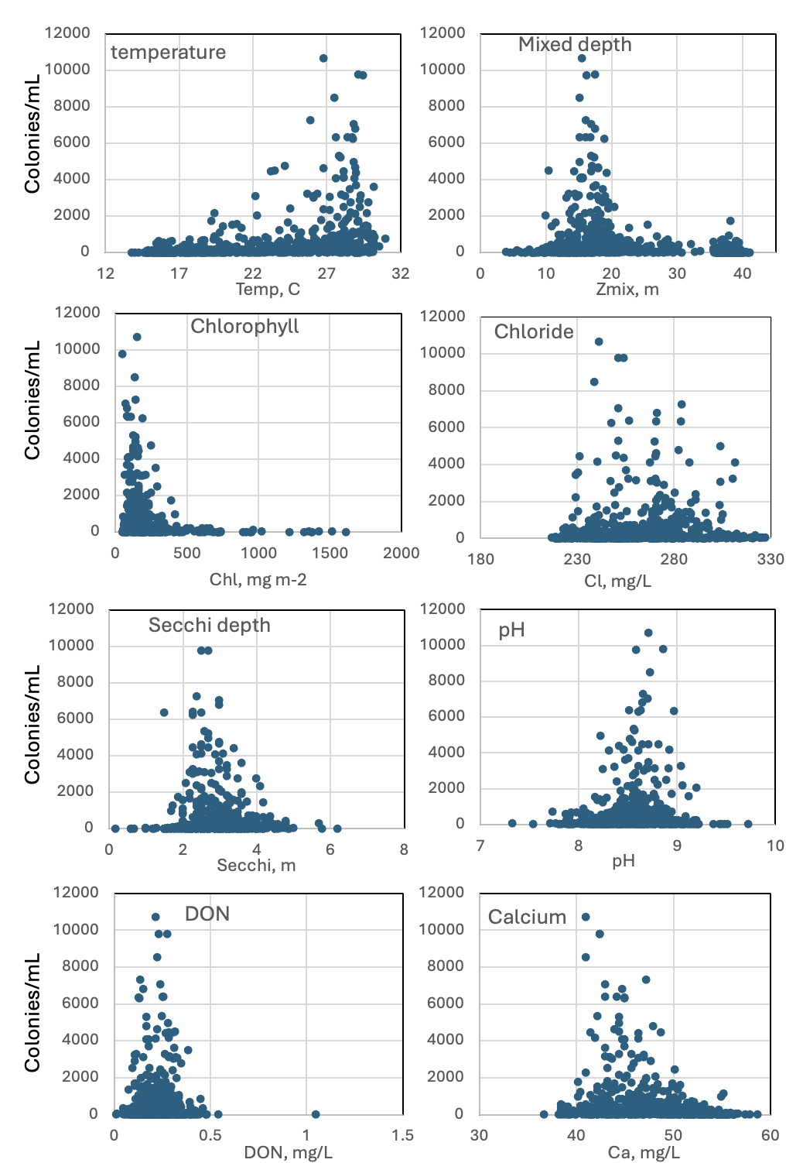

Figure 3. Cyanodictyon imperfectum abundance (colonies mL⁻¹) vs. environmental parameters recorded at the site and time of sampling.
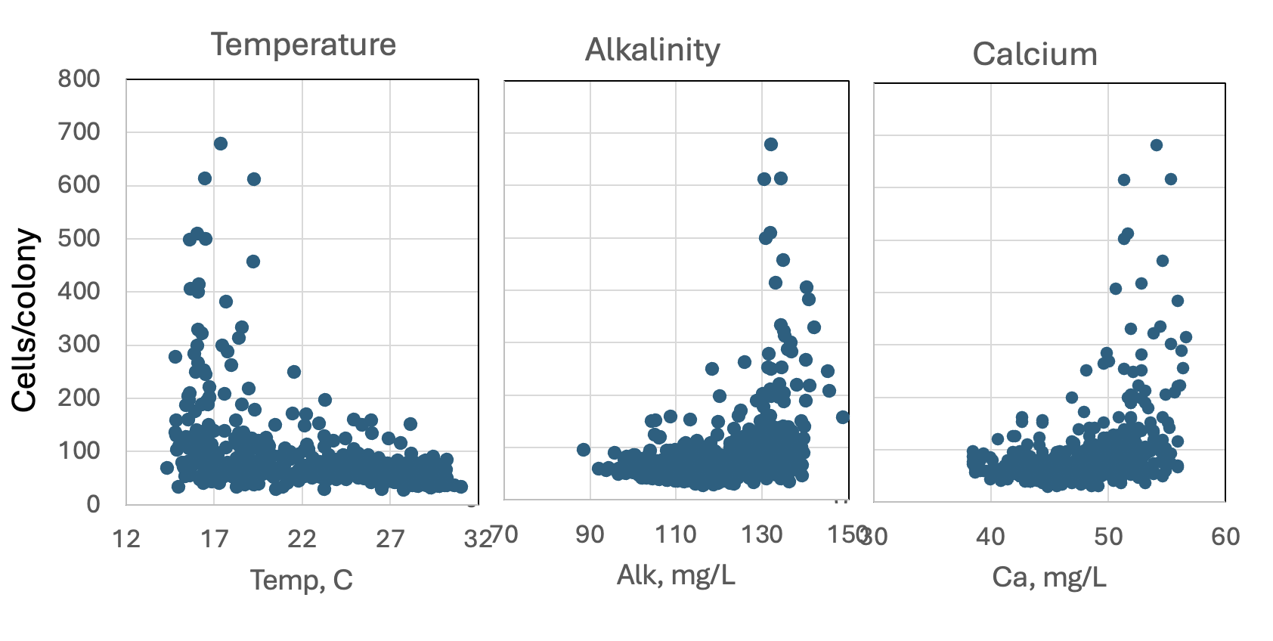Figure 4. Cyanodictyon imperfectum colony size (as the number of cells per colony) vs. environmental parameters recorded at the site and time of sampling, showing tendency for larger colonies at low ambient water temperature, higher alkalinities and higher Ca concentrations.

Cite this record as:
Tamar Zohary, Alla Alster. [Date when Item was last updated]. Electronic publication. Israel Oceanographic & Limnological Research. [Date when last accessed].
Further reading:
Cronberg G, Weibull C (1981) Cyanodictyon imperfectum, a new chroococcal blue-green alga from Lake Trummen, Sweden. Archiv für Hydrobiologie Supplement 60/2 (Algological Studies 27):101-110.
Hickel B, Pollingher U (1988) Mass development of an iron precipitating cyanophyte (Cyanodictyon imperfectum) in a subtropical lake (Lake Kinneret, Israel). Phycologia 27:291-294.
Zohary T, Fishbein T, Shlichter M, Naselli-Flores L (2017) Larger cell or colony size in winter, smaller in summer – a pattern shared by many species of Lake Kinneret phytoplankton. Inland Waters 7:200-209.
Radiocystis geminata Skuja 1948

Phylum: Cyanobacteriophyta
Class: Cyanophyceae
Order: Chroococcales

Habitat: planktonic
Distinctive features: colonies of spherical cells organized in radiating uniseriate rows extending from the center. No cyanotoxins are known for this species.
Organization: colonies
Color: blue-green
Cell shape: sphere
Colony shape: spherical (more or less)
Cell diameter (D): 1-3.7 µm; median: 2 μm; N=609
Cell biovolume: 0.5 – 25 μm³, median: 4 μm³; N=609
Biovolume equation: Sphere V, μm³ = 4/3 π (D/2)³
Colony diameter: up to 70 µm
Cells per colony: 40-100 (600)
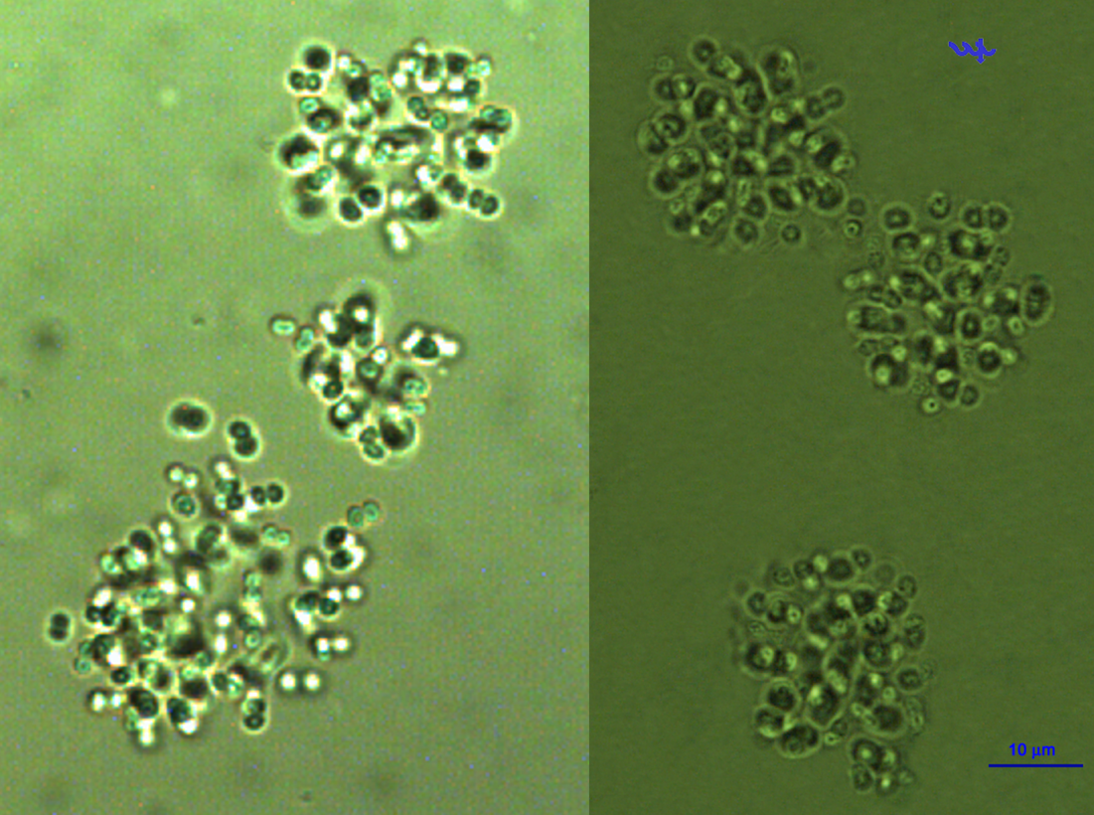
Plate 1. with 1 or more photos of the species, and descriptive text below each photo.Photo by Alla Alster.
Morphological features:
Colonies are more or less spherical or slightly elongate, made of small (2 µm) sperical cells organized in radiating uniseriate rows extending from the center to all directions, embedded in colorless mucilage (Plate 1). Cells with gas vesicles. Can be distinquished from Microcystis spp. by the smaller cell size and organization in radiating rows. Cell size varies only slightly, OK not to measure cell size routinely, use a median value instead.

Ecology: Radiocystis germinata has always been a member of the Kinneret plankton, although there were periods during which it was nearly absent (e,g, 1993-1995; 2005-2006; 2011-2014) but then it returned (Fig. 1). When present, it is often very abundant, with hundreds of colonies made of thousands of cells per mL (Fig. 1). Peak abundance is in summer, from july to September, while in winter the species is practically absent (Fig. 2). The number of cells in a colony shows a weak seasonal cycle, with larger colonies in winter and smaller in summer (Fig. 2). The variation in cell size is minor (Fig. 2).
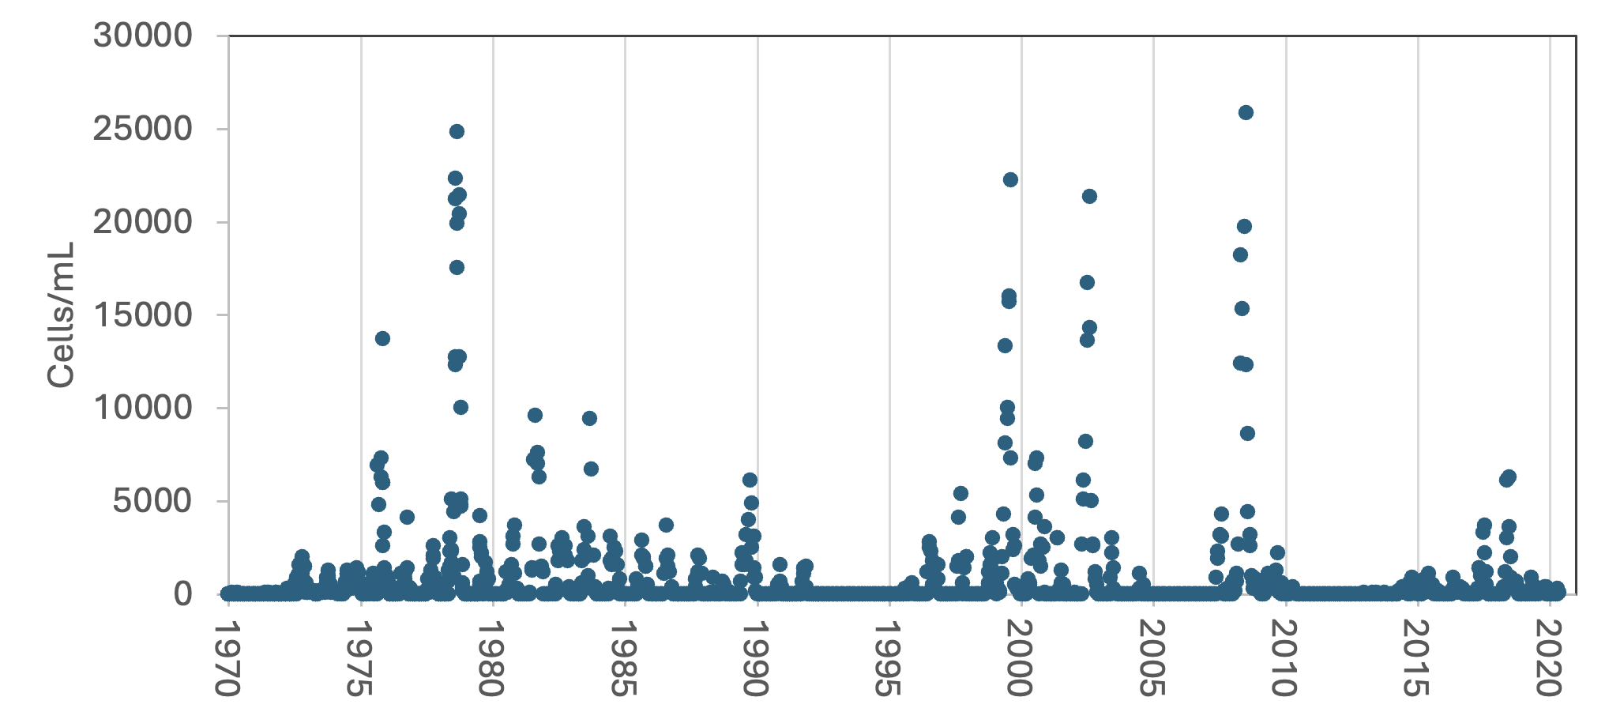
Figure 1. Time series of Radiocystis germinata mean epilimnion cell abundance (cells mL⁻¹), Lake Kinneret, 1970-2020

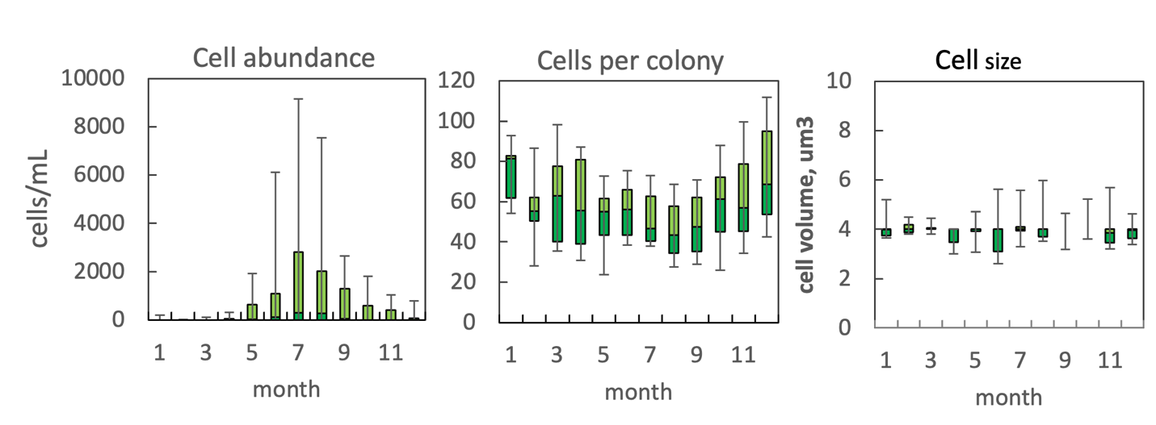
Figure 2. The annual pattern of water column cell abundance (left), colony size (middle) and cell size (right) of Radiocystis germinata, based on data for 2006-2014. Statistics shown are: median – middle line; 25th to 75th percentiles – box content; 90th and 10th percentiles - top and bottom bars, respectively.

Physiological features:

Environmental conditions: Abundance increases with water temperature. Indifferent to salinity at the range occurring in Kinneret. Most abundant when pH ranges 8.5-9, alkalinity 100-120 mg CaCO₃ mL⁻¹ (not shown).
Cite this record as:
Tamar Zohary, Alla Alster. [Date when Item was last updated]. Electronic publication. Israel Oceanographic & Limnological Research. [Date when last accessed].

